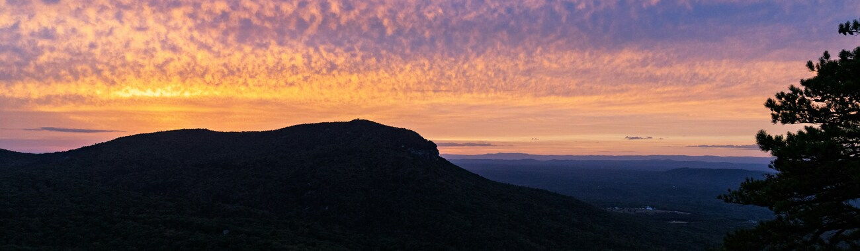
Sauratown Mountains at sunset, Danbury NC -- Deepak Adhikari / Unsplash
Hanging Rock State Park
Family Camping Trip
May 27-29, 2026 | Cabin 1 | Danbury, NC

The Crew
Adam | Dad
Papa (Terry) | Grandpa -- Ruth's dad
Grandpa (Dan) | Grandpa -- Adam's dad
David | Age 14
Aidan | Age 11
JJ | Age 7

Before You Go -- Key Notes

Check-in is at 3 PM. Cabin check-in is at the Visitor Center, which closes at 4:45 PM. Plan to arrive between 3 and 4:30.

Check-out is at noon. Leave keys on the kitchen table.

No cell service. Download maps and directions before leaving home. Screenshot or print this document.

The lake is Thu-Sun only. Swimming and boat rentals are not available Tuesday or Wednesday. Plan lake time for Thursday on the way out.

Late May wildflowers. Peak rhododendron and mountain laurel bloom -- see the plant guide later in this document.

Cabin 1 supplies. Bring your own: sheets (4 twin flat, 1 queen for the sleeper sofa), towels, toiletries. Cabin has full kitchen, central AC/heat, screened porch, charcoal grill and picnic table outside.

Firewood. Purchase from the Visitor Center or Camp Host (~$7/bundle). Communal fire rings are near the cabins.

Fishing. Grandpa Dan has a NC lifetime fishing license which covers the kids. Bring his gear and you're set.

Bikes -- no maps mid-ride. Note your route before heading out. No GPS signal in the park.

Day 1 -- Tuesday, May 27

Arrive and Settle In

8 - 10 am | Depart Fuquay-Varina after breakfast  About 2 to 2.5 hours. Download offline maps before leaving. Aim to arrive by 4 PM at the latest -- cabin check-in is at the Visitor Center which closes at 4:45.

En route | Optional stop -- Lower Cascades Falls  If you're making good time, the Lower Cascades parking area (2143 Hall Rd) is just outside the park gate. A short 0.8-mile round trip and a good way to stretch your legs before check-in.

3:00 pm | Check in at the Visitor Center  Get your key, pick up a trail map, and head to Cabin 1.

After check-in | Unload and get settled  Claim beds, unpack food, get oriented. Screened porch with rocking chairs is a good place to decompress after the drive.

Late afternoon | Bikes and lake trail  If Grandpa Dan is along: Adam + Dan on the tandem, David leading Aidan and JJ on park roads near the lake. If Dan is not there: David leads brothers. Papa can take the flat Lake Trail or sit on the porch.

Evening | Steak tip dinner  Tips are pre-marinated at home -- sear in the cast iron. Corn on the cob if good corn is available, bread, butter.

After dinner | Campfire and first night  Firewood from the Visitor Center or Camp Host (~$7/bundle). Communal fire rings near the cabins.

Day 2 -- Wednesday, May 28

Waterfalls, Trails, and Mountain Pies

8 - 9 am | Breakfast  Eggs, bacon, toast. Coffee on the screened porch.

9:30 am | Visitor Center -- whole group  Small museum, interactive exhibits, trail maps, and a deck overlook. Flat and easy -- good for Adam and Papa alike.

10:00 am | Upper Cascades Falls -- whole group  0.6-mile round trip, starts paved then crushed gravel. Accessible overlook deck -- Adam and Papa can stop here. The trail runs through rhododendron and mountain laurel in full bloom. Anyone who wants to scramble down to the base can from the deck.

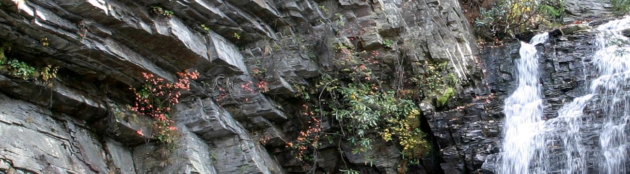
Lower Cascades Falls, Hanging Rock State Park -- Kylem322 / CC BY 3.0 via Wikimedia Commons

Around 11:00 am | Options -- split or stay together  Lower Cascades Falls (0.8 mi, swimming hole at the base, 2143 Hall Rd). Mountain bike singletrack (2568 Moores Spring Rd). Or stay at the cabin or lake area.

Around noon | Regroup and lunch  Hot dogs and brats on the charcoal grill outside the cabin. Hot dogs for JJ, brats for everyone else. Eat when everyone is back.

2:00 - 4:30 pm | Free afternoon  Bikes on park roads, fishing off the lake pier (Grandpa Dan's lifetime license covers the kids), porch time, exploring around the cabin.

Late afternoon (optional) | Tory's Den Cave  Short hike from 1185 Charlie Young Rd to a Revolutionary War-era cave hideout. Go if it works, skip if it doesn't.

5:30 pm | Pizza mountain pies -- campfire  Dan's mountain pie makers out. Each kid makes their own -- butter the bread, add sauce, mozzarella, pepperoni, press and hold over the coals. Start early and make it a process.

After dinner | S'mores and stargazing  Graham crackers, chocolate, marshmallows. Minimal light pollution out here.


Photo: Justin Wolff / Unsplash

Day 3 -- Thursday, May 29

Easy Morning, Scenic Drive Home

Morning | Smoothies and easy breakfast  Protein shakes for Adam, Grandpa Dan, and David. Adam has one shaker cup -- check with Dan on his, may need to pick up an extra. Cereal or granola bars for Papa, Aidan, and JJ.

By noon | Pack up and check out  Check-out is noon. Leave keys on the kitchen table.

~12:30 pm | Pilot Mountain State Park  About 25 minutes from Hanging Rock. Drive-to overlook -- the Big Pinnacle knob with zero hiking required. Free. 15-20 minutes.

~1:30 pm | Mount Airy -- Mayberry  About 30 minutes from Pilot Mountain. The town that inspired The Andy Griffith Show. Flat and walkable.

- Mayberry Replica Jailhouse (free) -- get locked in Otis's cell for the photo.
- Wally's Service Station (free) -- vintage squad cars, Mayberry photo ops.
- Granite Quarry Observation Deck (free) -- largest open-face granite quarry in the US.
- Andy Griffith Museum (optional, $8 adults / $6 kids)

~2:30 pm | Lunch in Mount Airy  Snappy Lunch for the famous pork chop sandwich (cash only) or Leon's Burgers. Eat before the drive.

~3:30 pm | Head home to Fuquay-Varina  About 2 hours. Everyone except the driver will sleep in the car -- which is fine, because someone has to make sure you end up in Fuquay and not Fayetteville.

Pilot Mountain to Mayberry adds maybe 45 minutes to the drive but turns checkout day into the final act of the trip.

Meal Plan

Meal | What | Notes
Tue dinner | Steak tips | Pre-marinate at home. Cast iron sear. Corn if available, bread, butter.
Wed breakfast | Eggs, bacon, toast | On the cabin stove.
Wed lunch | Hot dogs and brats | Charcoal grill outside the cabin. Hot dogs for JJ, brats for everyone else.
Wed dinner | Pizza mountain pies | Dan's pie makers. Pepperoni, sauce, mozzarella, sturdy sandwich bread, butter.
Wed after dinner | S'mores | Graham crackers, chocolate bars, marshmallows.
Thu breakfast | Smoothies and cereal | Shaker cups for Adam, Dan, David. Cereal/granola bars for others.
Thu lunch | Snappy Lunch or Leon's | Mount Airy. Eat before the drive. Snappy Lunch is cash only.

What to Pack

Cabin Essentials -- Not Provided
- Sheets: 4 twin flat sheets, 1 queen fitted sheet for the sleeper sofa
- Towels and washcloths for everyone
- Toiletries, soap, shampoo
- Paper towels, dish soap, sponge
- Trash bags
- Coffee and filters (cabin has a coffee maker)

Clothing and Personal Items
- Clothes for 3 days including layers -- mornings can be cool in late May
- Rain jacket -- May weather is variable
- Sturdy shoes or hiking sandals for trails
- Swimwear if anyone plans to get in the water
- Sunscreen and bug spray
- Toothbrush, toothpaste, any medications

Food and Kitchen
- Steak tips -- pre-marinated in a sealed bag
- Corn on the cob if good corn is available, bread, butter
- Eggs, bacon, bread for toast
- Hot dogs and brats, buns, mustard, ketchup
- Sturdy sandwich bread (for mountain pies), pizza sauce, shredded mozzarella, pepperoni
- Graham crackers, chocolate bars, marshmallows
- Protein powder, shaker cups (Adam has one -- check with Dan, may need an extra)
- Cereal and granola bars
- Snacks, drinks, water bottles, ice
- Cast iron skillet if you prefer a good sear over the cabin cookware

Activities and Gear
- Bikes: David's eBike, tandem, Aidan's bike, JJ's bike
- Helmets for all riders
- Dan's mountain pie makers -- ideally 3 or more for the group
- Fishing gear -- Grandpa Dan's NC lifetime license covers the kids
- Headlamps or flashlights for after dark
- Camp chairs -- good to have more seating at the fire ring

What's Blooming -- Late May at Hanging Rock

The park's elevation and isolation from the Blue Ridge gives it a botanical character more like the western mountains -- plants rarely seen this far east. Late May is peak bloom season.

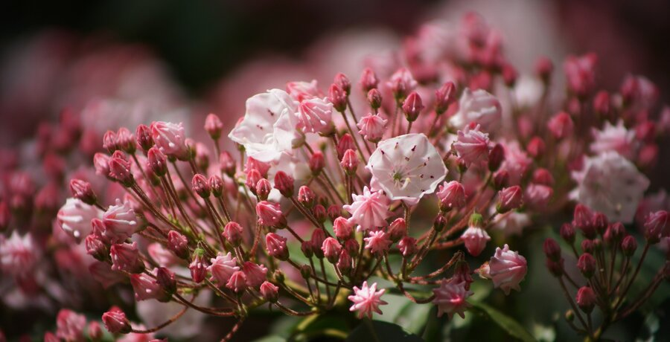
Mountain laurel (Kalmia latifolia) -- Jasper Shide / CC0 Public Domain

Plant | Notes
Catawba Rhododendron | Bright magenta-pink clusters, peak bloom late May through early June. Most visible on the upper trails alongside mountain laurel at all elevations.
Mountain Laurel | White and pale pink clusters with distinctive crimped buds. The buds look like tiny folded parasols before they open.
Pinxter Azalea | Coral-pink with long protruding stamens. Scattered through the forest understory.
Pink Lady's Slipper | A native terrestrial orchid, rare and protected. Found on rocky outcrops in acidic soils. Look down on the higher trails.
Fire Pink | Vivid scarlet five-petaled flower on wiry stems. Common on rocky ledges and dry slopes. Attracts hummingbirds.
Galax | Evergreen groundcover with round glossy leaves. White flower spikes emerge in late May. Common along all the trails.
Bird-Foot Violet | Deep purple-blue violet found in rocky, thin soil. May be past peak by late May but still possible on the outcrops.
Turkey-Beard | Tall white flower spike on a grassy-leaved plant. Found on exposed rocky ridges. Blooms late May through June.

All plants in NC State Parks are protected. Collecting is not permitted.

Activity Guide -- Don't Miss It

Inside Hanging Rock State Park

Activity | Notes
Visitor Center and Museum | Free, flat, air conditioned. Deck overlook. Good first stop for the whole group. Pick up trail maps here.
Upper Cascades Falls | 0.6 mi round trip. Accessible overlook deck -- good for Adam and Papa. Trail runs through rhododendron in full bloom. Stairs to the base for anyone who wants to go further.
Lower Cascades Falls | 0.8 mi round trip. Steep stairs at end. Swimming hole at the base. Separate parking at 2143 Hall Rd.
Window Falls and Hidden Falls | 1.2 mi round trip. Moderate. Water flows through a natural hole in the rock face at Window Falls.
Tory's Den Cave | Short hike from 1185 Charlie Young Rd. Revolutionary War hideout cave. Optional.
Rock Garden Trail | 0.2 mi, paved and flat. Good for Adam and Papa. Massive boulders right at the visitor center.
Lake Trail | Easy lakeside walk -- pavement, gravel, boardwalk. Fishing pier and benches. Good for everyone.
Mountain Bike Trails | 15 miles of intermediate singletrack. Separate access at 2568 Moores Spring Rd.
The geology story | These quartzite peaks are remnants of a range worn down over 500+ million years -- some of the oldest exposed rock in the eastern US.

The Drive Home Sequence

Stop | Notes
Pilot Mountain State Park (~25 min) | Iconic Big Pinnacle knob visible from the overlook -- no hiking needed. Free.
Granite Quarry Overlook, Mount Airy (free) | Largest open-face granite quarry in the US. Most visitors don't know it's there.
Mayberry Replica Jailhouse (free) | Get locked in Otis's cell for the photo.
Wally's Service Station (free) | Vintage squad cars, photo ops, Mayberry gift shop.
Andy Griffith Museum ($8 / $6) | Props, costumes, memorabilia. Optional.
Snappy Lunch | Famous pork chop sandwich since the 1920s. Cash only.

Trail Quick Reference

Trail | Distance | Notes
Rock Garden Trail | 0.2 mi RT | Paved, flat. Good for Adam and Papa.
Upper Cascades Falls | 0.6 mi RT | Easy. Accessible overlook. Whole group.
Lake Trail | ~1 mi loop | Easy. Lakeside. Good for everyone.
Lower Cascades Falls | 0.8 mi RT | Moderate. Steep stairs. Swimming hole.
Window + Hidden Falls | 1.2 mi RT | Moderate. Rock window feature.
Tory's Den Cave | ~0.5 mi RT | Moderate. Cave with history. Optional.
Mountain Bike Trails | Up to 15 mi | Intermediate singletrack. Separate access.

Key Addresses and Contacts

Location | Info
Hanging Rock State Park | (336) 593-8480
Cabin / main entrance | 1790 Hanging Rock Park Rd, Danbury, NC 27016
Lower Cascades parking | 2143 Hall Rd, Westfield, NC 27053
Mountain bike trail access | 2568 Moores Spring Rd, Westfield, NC 27053
Tory's Den parking | 1185 Charlie Young Rd, Westfield, NC 27053
Pilot Mountain State Park | 1792 Pilot Knob Park Rd, Pinnacle, NC -- free admission
Snappy Lunch (cash only) | 125 N Main St, Mount Airy, NC
Mayberry Jailhouse / Wally's | 625 S Main St, Mount Airy, NC

No cell service in the park. Screenshot or print this document before you leave home.

